S3 task = (Simple Storage Service)
1. Create an S3 bucket & upload objects
- Go to AWS Console → S3.
- Click Create bucket.
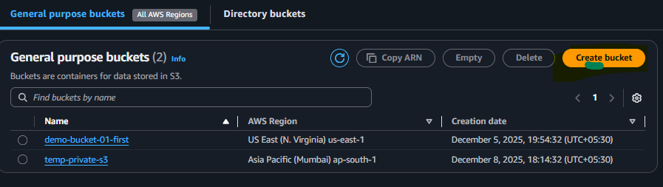
Now add your bucket name and reset leave as default settings then click on create bucket
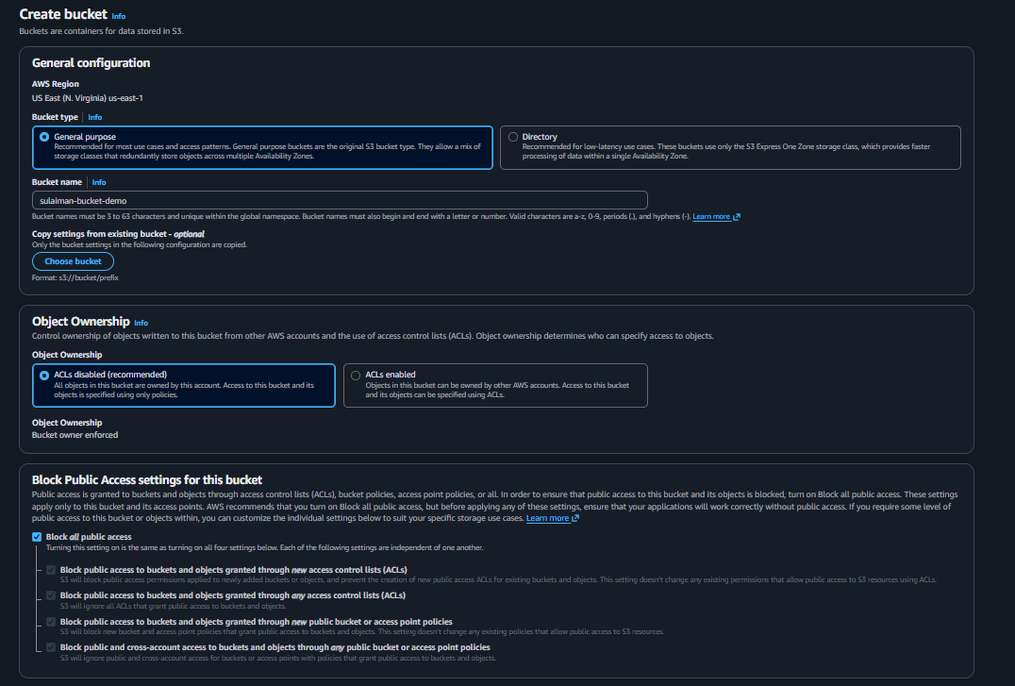
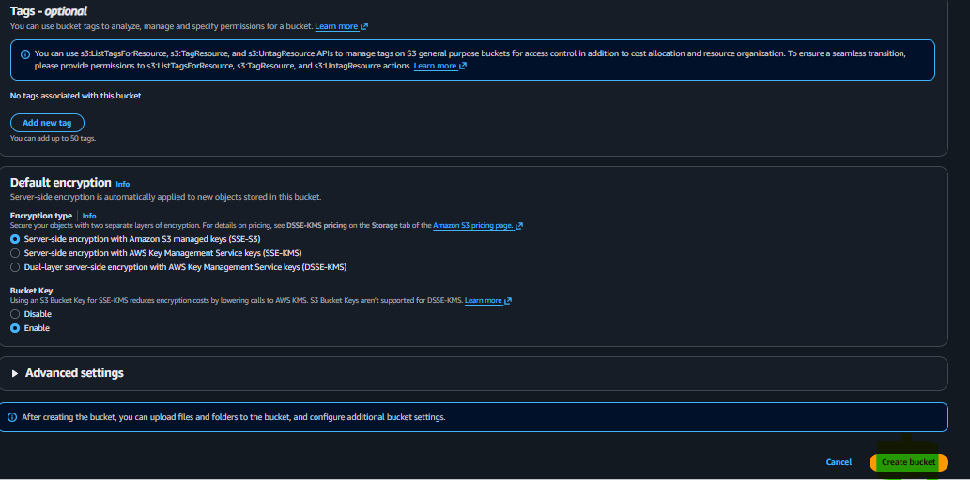
Now our bucket is successfully create as it visible on screen
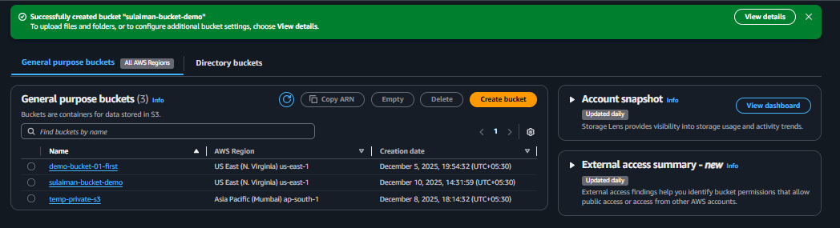
Now we need upload anything on our bucket simply click on upload and then add file – then upload that it
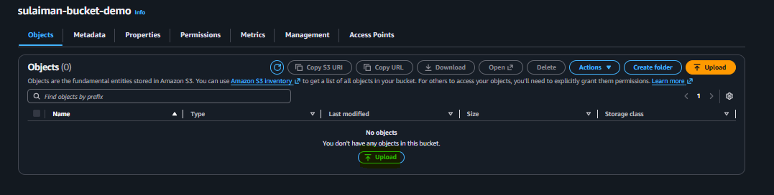
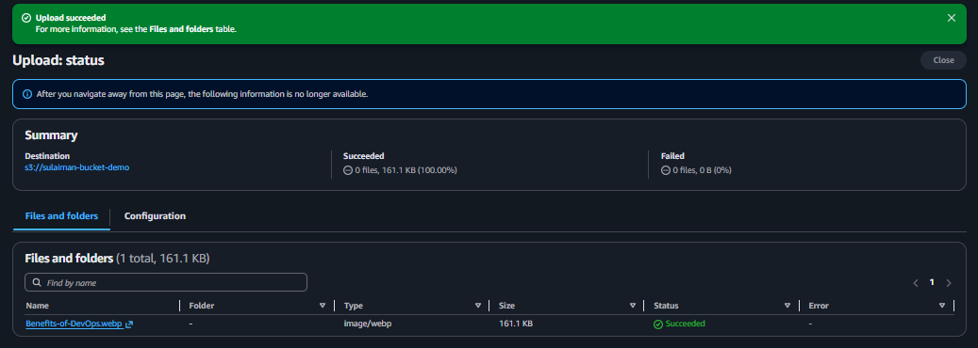

2. Deploy a static website in S3
Now goes inside properties
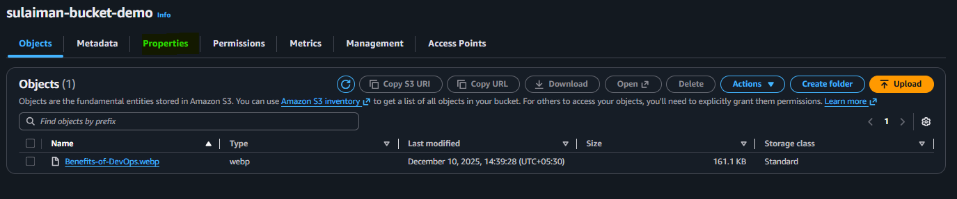
Scroll to Static website hosting -> Click Edit.
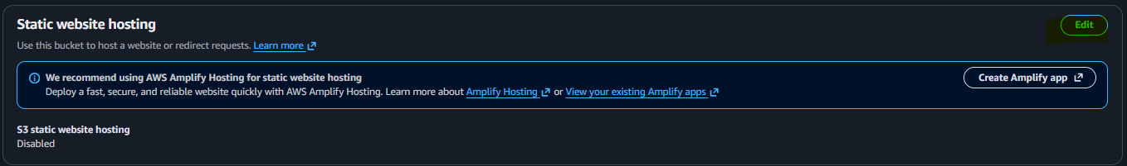
Click on enable
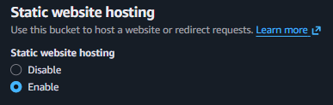
Now create make two file xyz.html and error.html
Then copy url error.html and html both file upload on your bucket then if in case any problem in html it view error.html
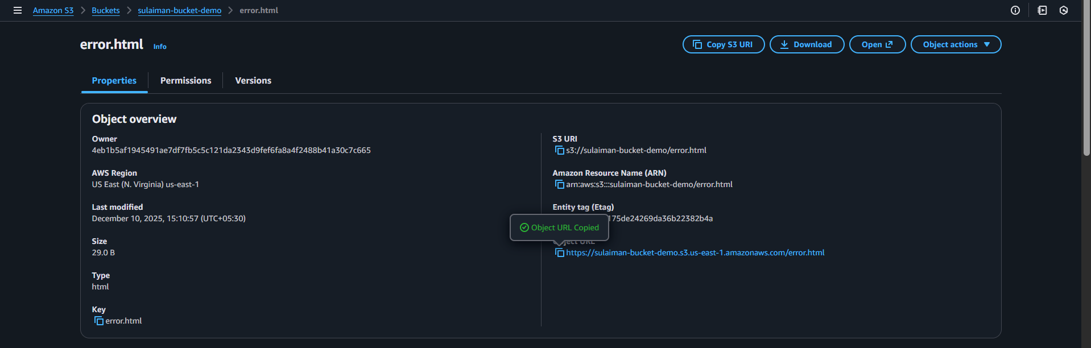
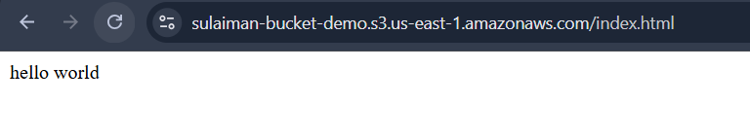

Now our idex.html successfully uploaded if there any error in our html it redirect user to this page
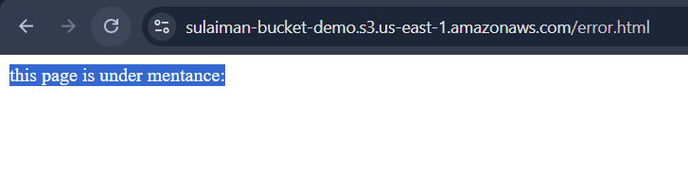
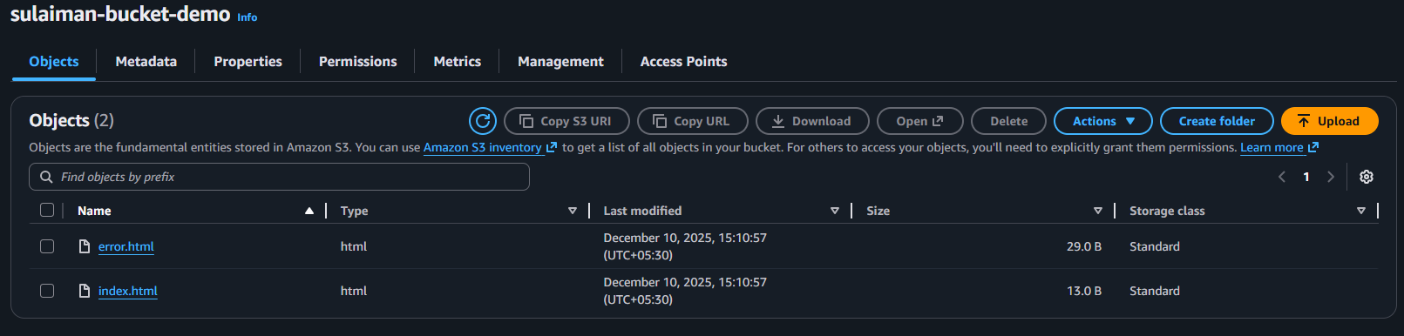

3. Enable cross-region replication on S3 buckets.
Now crate two diffrennt regions bucket
- Create Source bucket
- Create Destination bucket
Make sure this bucket different regions
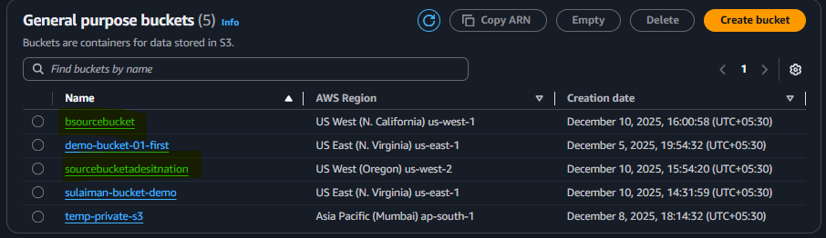
Now pickup a pickup destination bucket goes to inside in Go to each bucket → Properties tab → Versioning Turn ON → Save
Now create replication rule
1. Open your Source Bucket (Bucket A)
This is the bucket from which objects will replicate.
2. Click Management tab
(You'll see Replication section)
3. Click Create replication rule
4. Fill in the form:
Rule Name:
Cross any name
Status:
Enabled
Source:
- Choose All objects in bucket (or specific prefix if required)
Destination:
- Select your Bucket B (the bucket in another region)

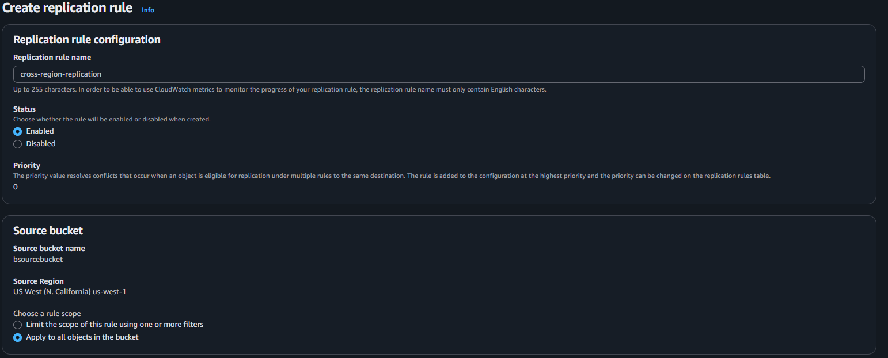
After this click on save
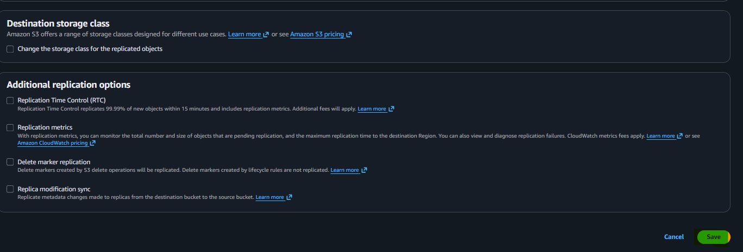
Now we can sent any file from source to destination
Test is our folder where sending a to b
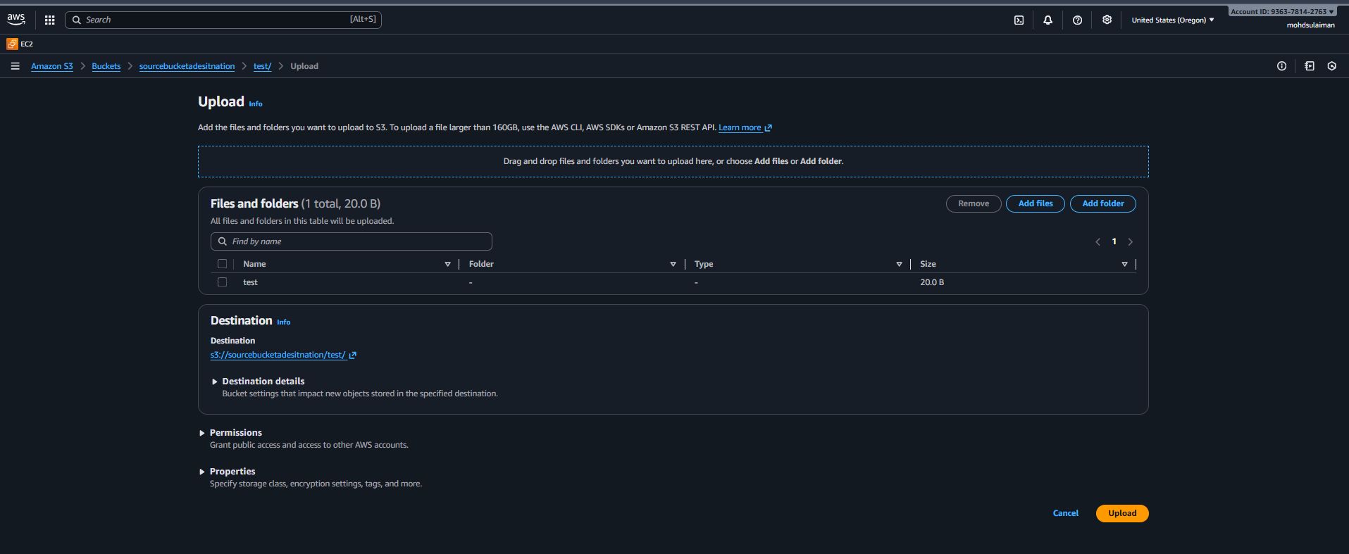
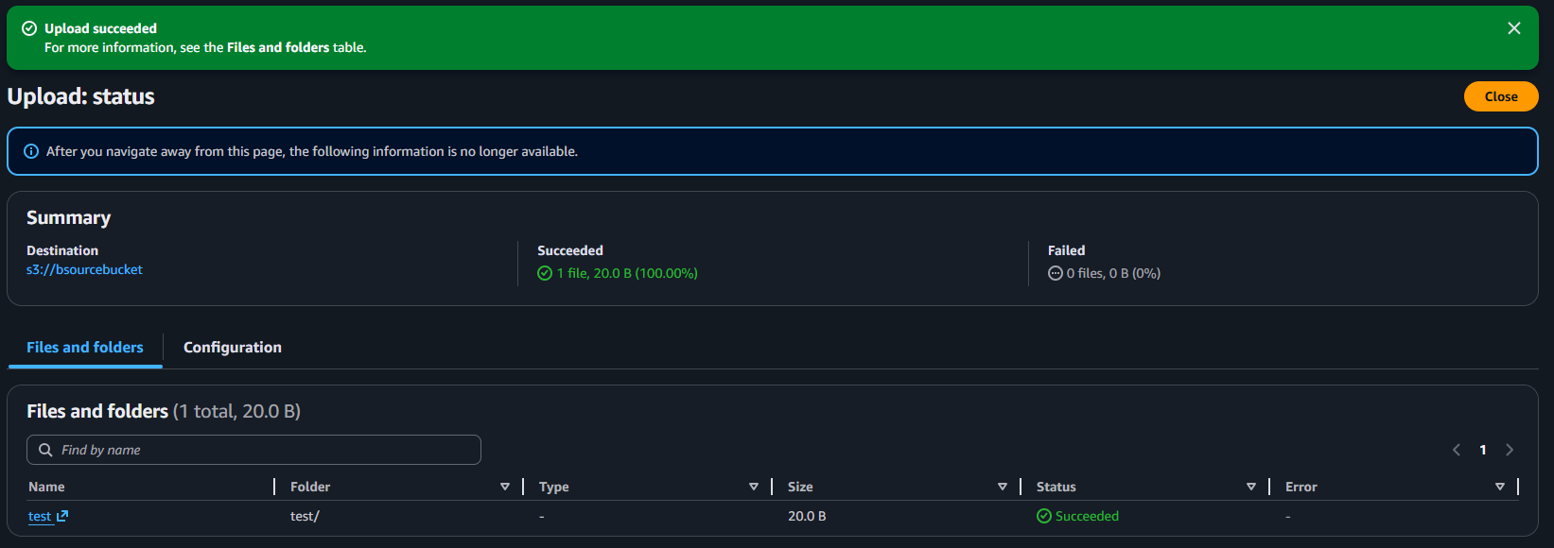
After sending this reload your source b onece load it it show file
Yea now folder successfully visable on another source means it working
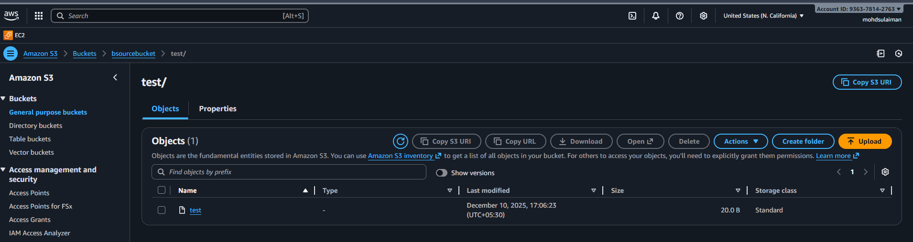

4. Configure a bucket policy so only the Admin user can see the objects of the S3 bucket.
Go to IAM and create the user and give the full access to the s3 bucket
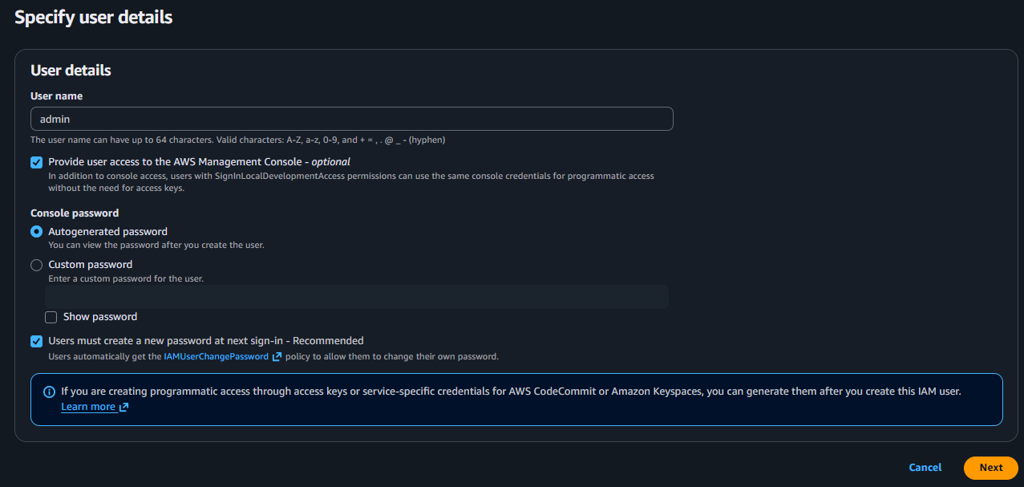
Next give it permission ( amazons3fullaccess) ticket
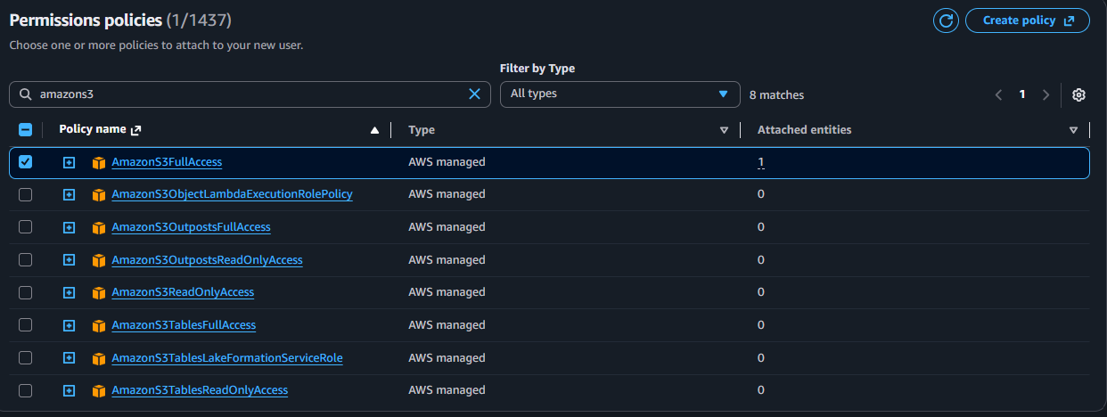

Now our user has been create verfy it permission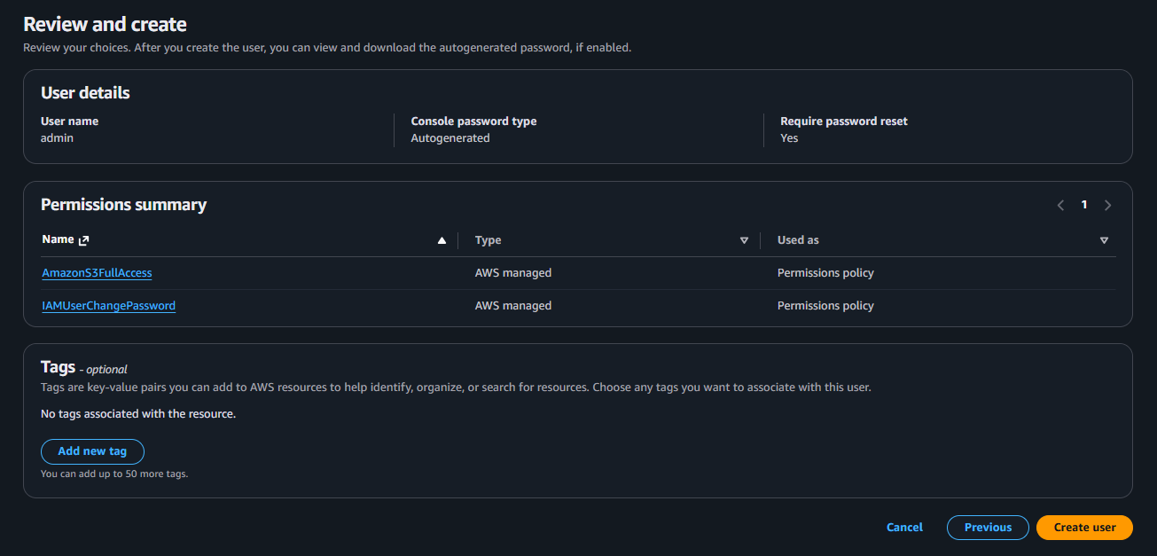
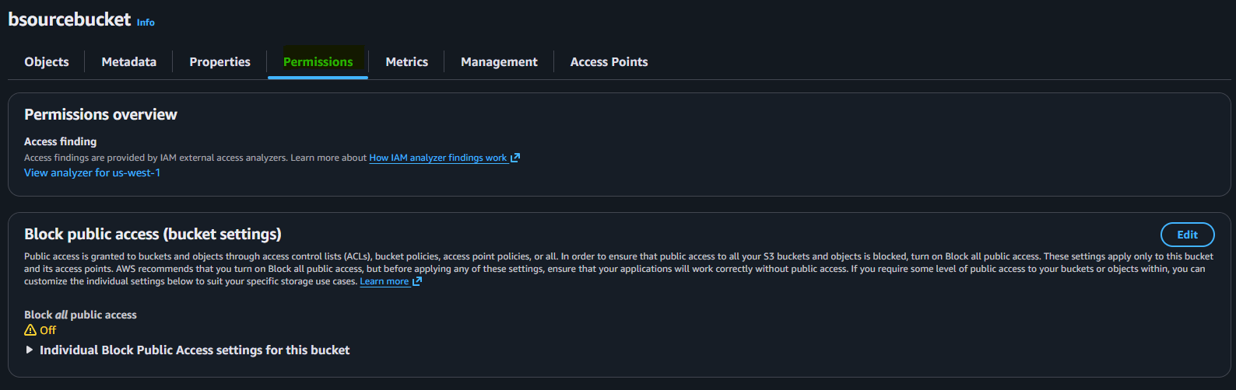
After writing code click on save changes

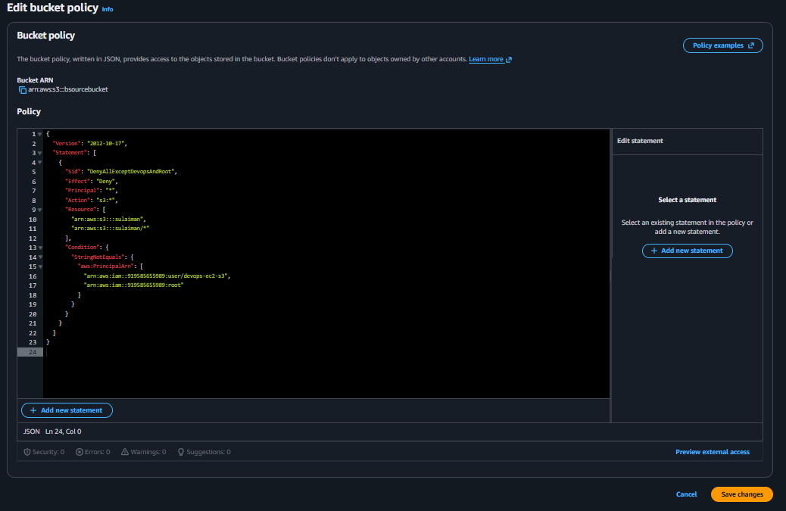

5. Set up lifecycle policies to automatically transition or delete objects based on specific criteria.
Go to the bucket and management create life cycle
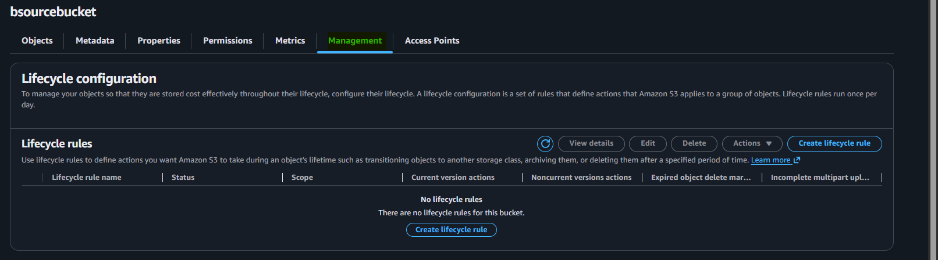

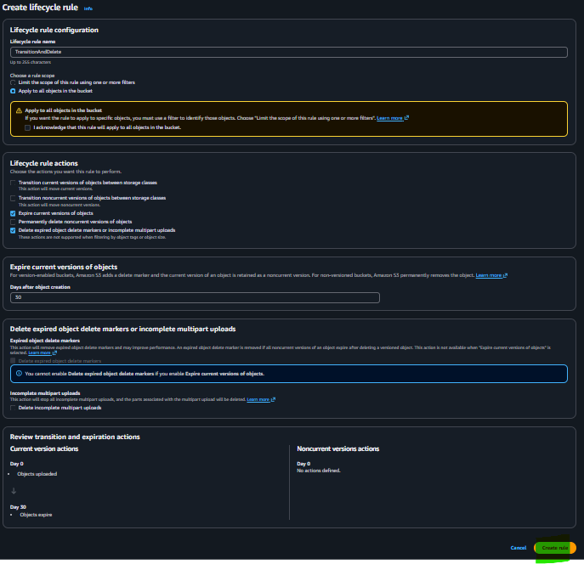
Now write rule name
- Ticket this two options
Expire current versions of objects
- Delete expired object delete markers or incomplete multipart uploads
That’s it now click on create rule

Successfully life cycle configuration is created
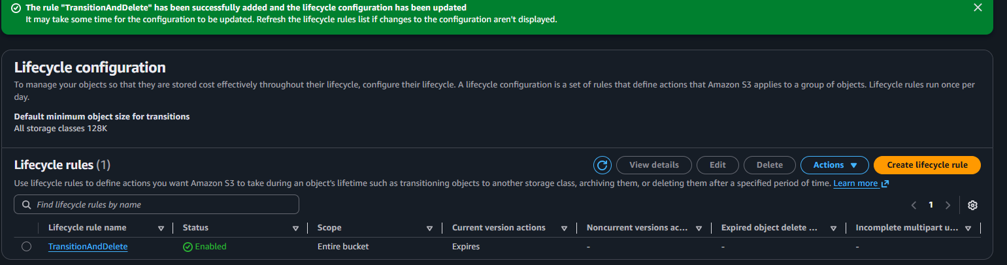

6. Push some objects to S3 using the AWS CLI.
First configure you access key and secret accceskey
Then make light file command ( echo “hello from cli upload” > test.txt)
Then push command ( aws s3 cp test.txt s3:\\ your bucket name/
That it reload your bucket once
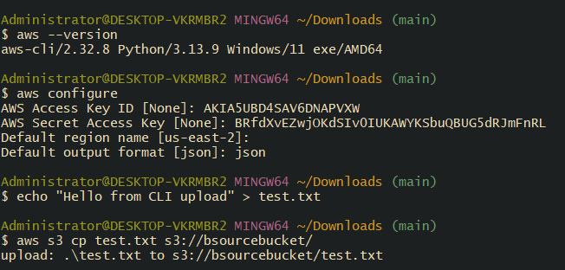
Now you see our text have seen upload it successfully
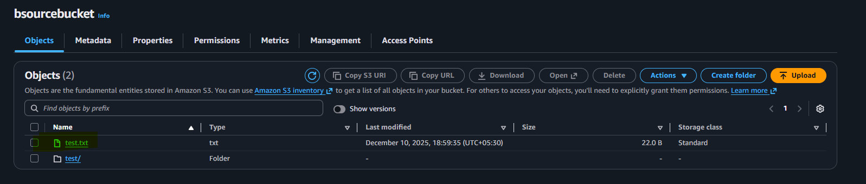

7 Write a Bash script to create an S3 bucket.
Creating the script to create the buket
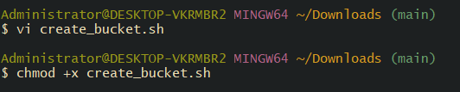
Make sure give unique name to bucket
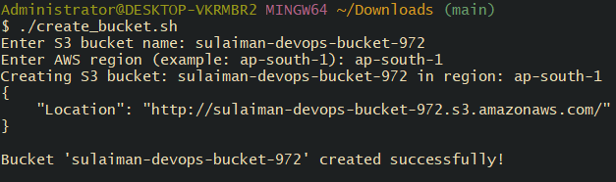
We have successfully create bucket
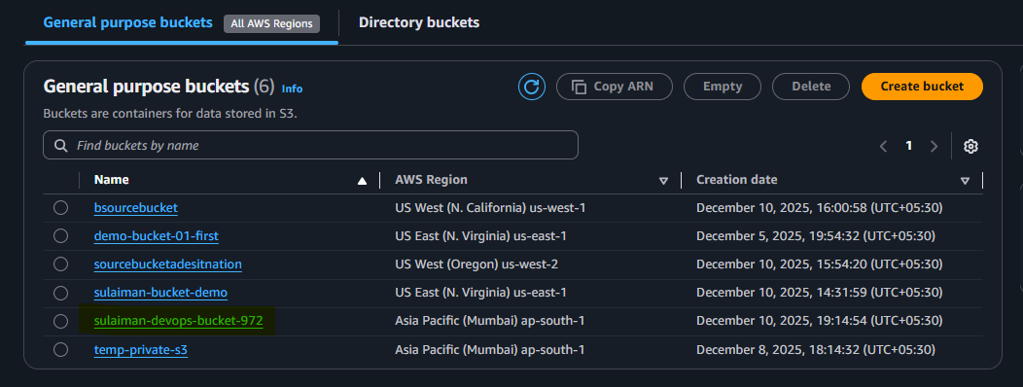
8. Upload a 1 GB file to S3 using the CLI. Uploaded the 1gb file in CLI
We need 1gb file then
Then type this command ( aws s3 cp "task-folder" s3://bsourcebucket/task-folder/ --recursive) then upload it it may take some task
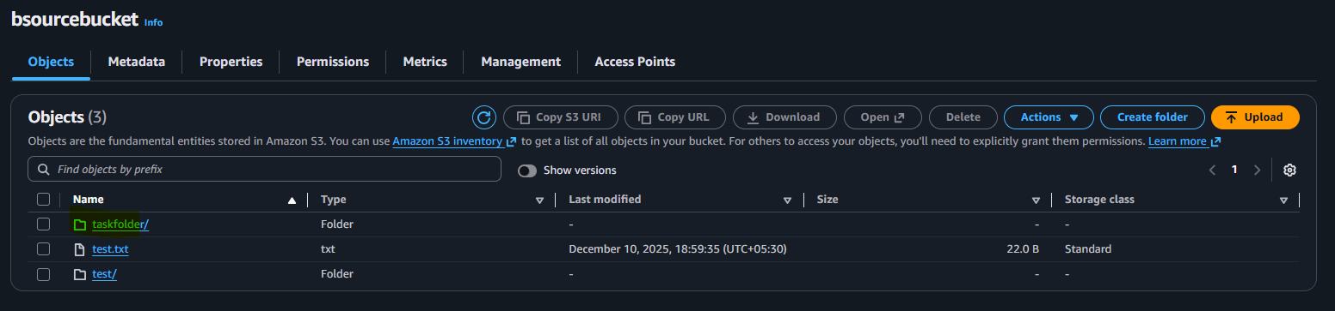
You see our 2 videos successfully upload on bucket throw desktop to s3
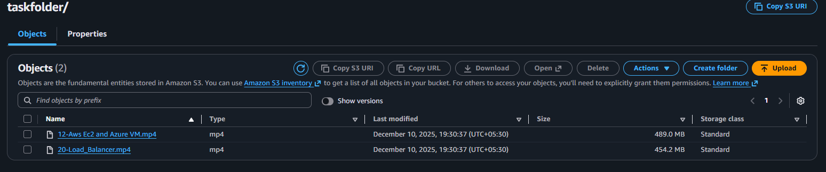
Thanks for revive my task

